Xeno Implementation Internship – Assignment.
Submitted by : Sudeep Kumar
Registration No: RA2311026010202
Assignment Tasks
1. SQL & Data Familiarity
Question\Answers:
- What steps would you take to review this data before importing it into a system? Please explain the process in not more than 3 lines.
Ans: Review for missing/null values in critical fields like customer_id and email to ensure data integrity. Check for duplicate records and verify that data types (e.g., signup_date as DATE) are consistent. Finally, validate that categorical data like city has standard spelling and formatting.
- Please execute each of the queries and support your queries with a screenshot of your results.
- Write a query to display all customers from the city 'Delhi'.
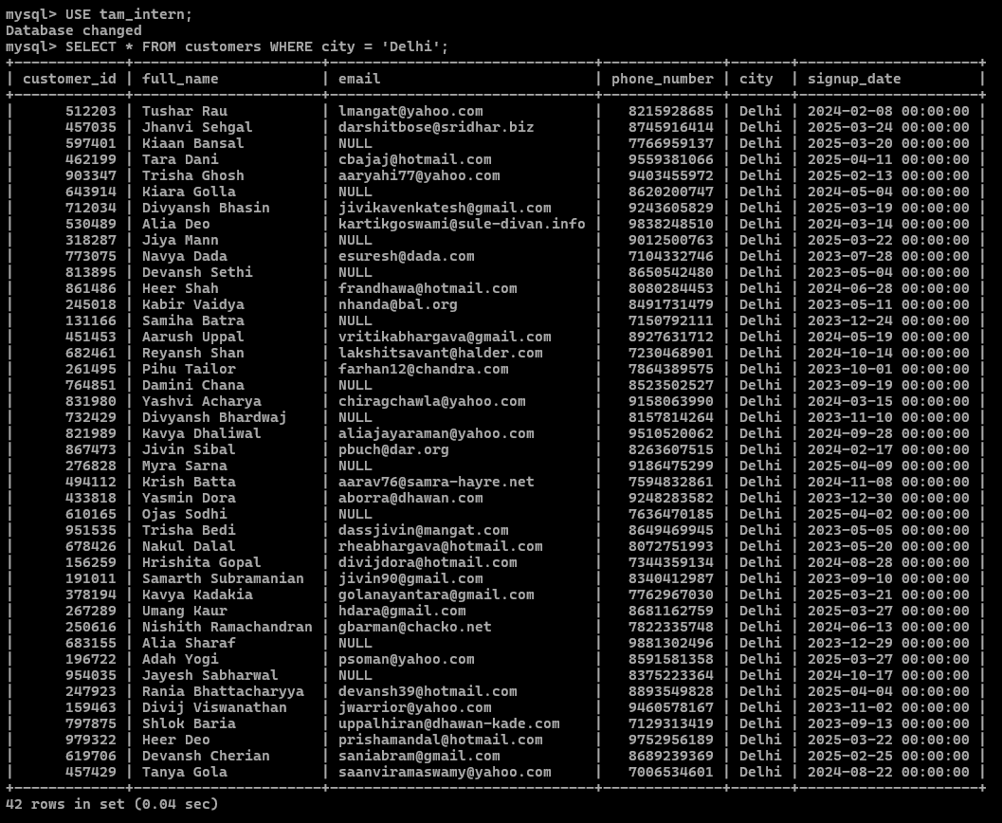
SELECT * FROM customers WHERE city = 'Delhi';

- Count the number of signups in the last 30 days. Assume today to be 16th April 2025
SELECT COUNT(*) AS recent_signups
FROM customers
WHERE signup_date >= DATE_SUB('2025-04-16', INTERVAL 30 DAY)
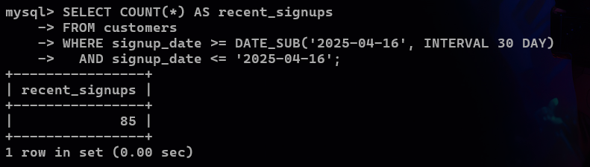
AND signup_date <= '2025-04-16';

- List unique cities where customers are based
SELECT DISTINCT city FROM customers;
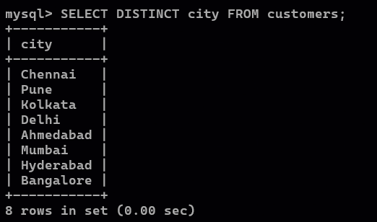

- List the top 3 cities by number of signups.
SELECT city, COUNT(*) AS total_signups
FROM customers
GROUP BY city
ORDER BY total_signups DESC
LIMIT 3;
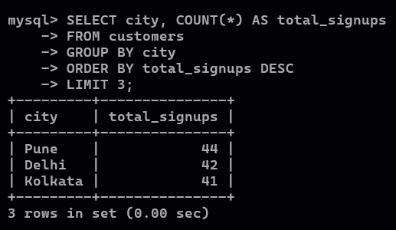

- Assume there’s another table orders (customer_id, order_id, amount). How would you find customers who have never placed an order?
SELECT c.*
FROM customers c
LEFT JOIN orders o ON c.customer_id = o.customer_id
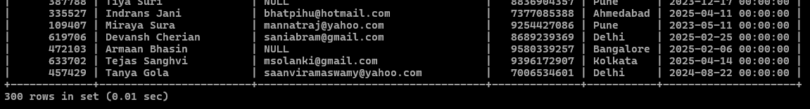
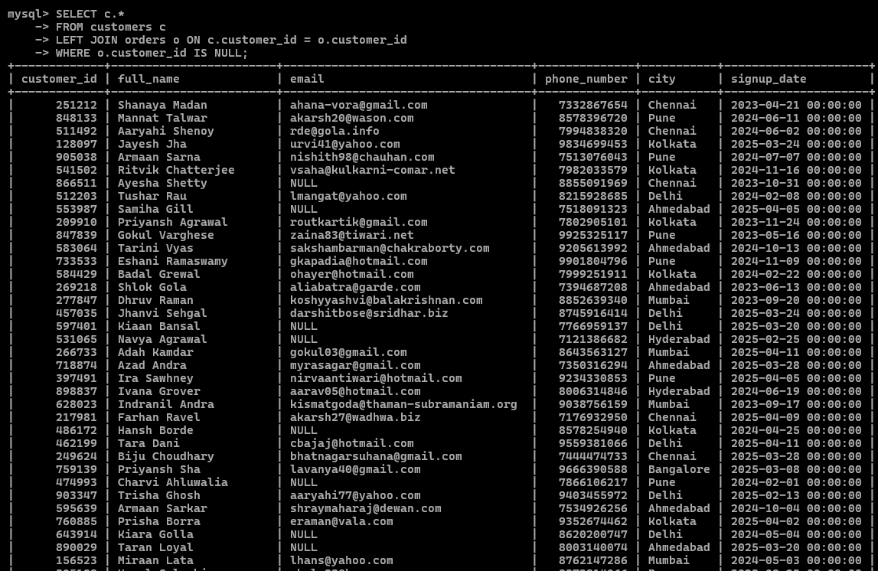
WHERE o.customer_id IS NULL;

- Data Transformation & Enrichment
Question\Answers:
- Add a new column to show if the email domain is ‘gmail.com’ or not. Fill it with ‘Yes’ or ‘No.
ALTER TABLE customers ADD COLUMN is_gmail VARCHAR(3);
UPDATE customers SET is_gmail = IF(email LIKE '%@gmail.com', 'Yes', 'No');
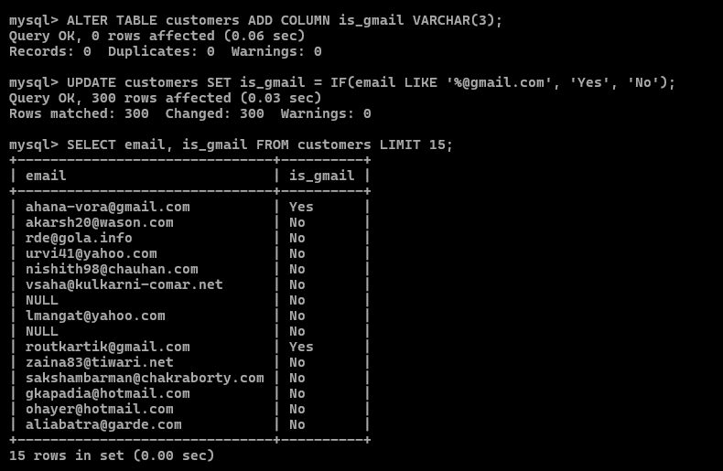
SELECT email, is_gmail FROM customers LIMIT 15;

- Extract the first name from the name column and store it in ‘first_name’
ALTER TABLE customers ADD COLUMN first_name VARCHAR(100);
UPDATE customers SET first_name = SUBSTRING_INDEX(full_name, ' ', 1);
SELECT full_name, first_name FROM customers LIMIT 15;
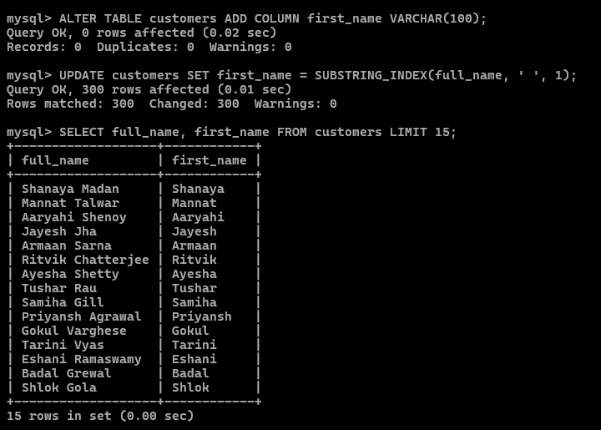
- Add a column ‘signup_month’ to capture the month name the customer signed up.
ALTER TABLE customers ADD COLUMN signup_month VARCHAR(20);
UPDATE customers SET signup_month = MONTHNAME(signup_date);
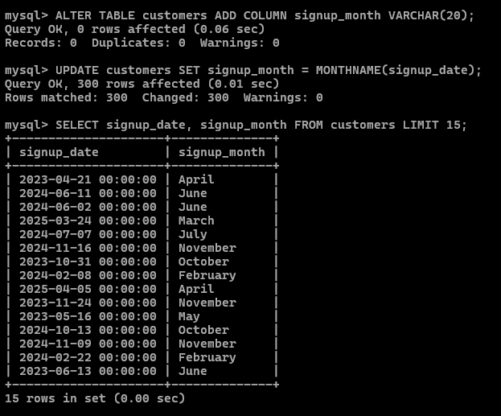
SELECT signup_date, signup_month FROM customers LIMIT 15;

- Create a report which shows the no. of GMAIL customers who have signed up for each day of the week.
SELECT
DAYNAME(signup_date) AS day_of_week,
COUNT(*) AS gmail_signups
FROM customers
WHERE is_gmail = 'Yes'
GROUP BY day_of_week
ORDER BY gmail_signups DESC;
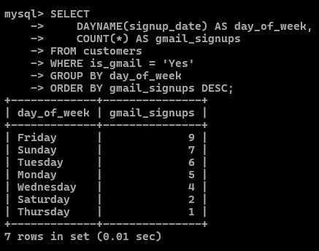

- Create a new table ‘vip_customers’ with customers from Delhi, Mumbai and Bangalore who have signed up in the last 60 days from 16th April 2025.
CREATE TABLE vip_customers AS
SELECT * FROM customers
WHERE city IN ('Delhi', 'Mumbai', 'Bangalore')
AND signup_date >= DATE_SUB('2025-04-16', INTERVAL 60 DAY)
AND signup_date <= '2025-04-16';
SELECT * FROM vip_customers LIMIT 15;

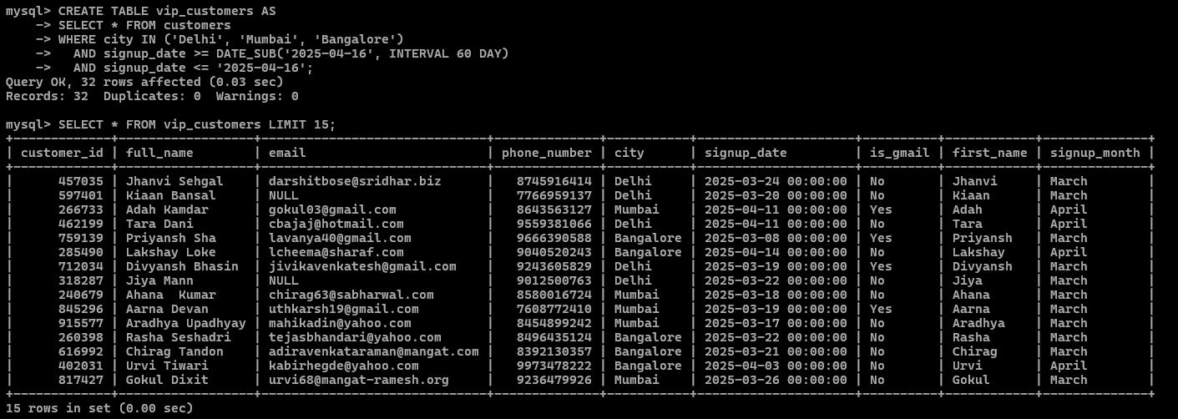
3. Analytics & Reporting
Question\Answers:
Write SQL queries for the following:
- Show a monthly signup count for the past 6 months.
SELECT
DATE_FORMAT(signup_date, '%Y-%m') AS signup_month_year,
COUNT(*) AS signup_count
FROM customers
WHERE signup_date >= DATE_SUB('2025-04-16', INTERVAL 6 MONTH)
AND signup_date <= '2025-04-16'
GROUP BY signup_month_year
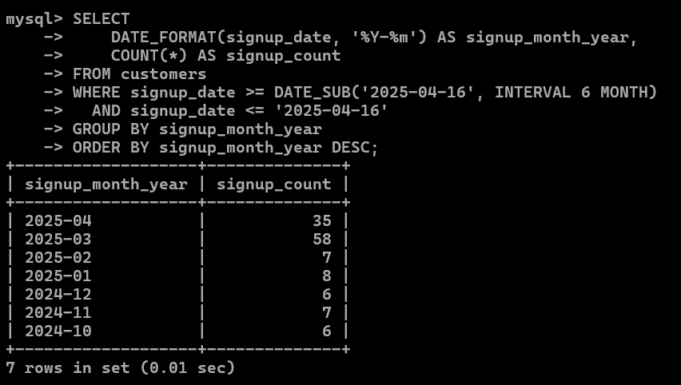
ORDER BY signup_month_year DESC;

- Get a list of cities with more than 20 customers.
SELECT
city,
COUNT(*) AS customer_count
FROM customers
GROUP BY city
HAVING COUNT(*) > 20
ORDER BY customer_count DESC;
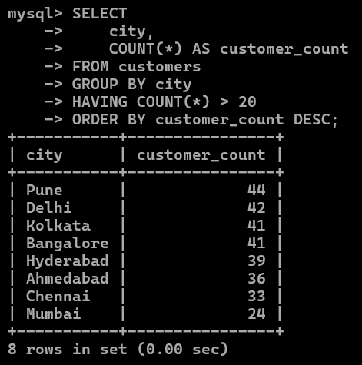

- Find the date with the highest number of signups.
SELECT
signup_date,
COUNT(*) AS total_signups
FROM customers
GROUP BY signup_date
ORDER BY total_signups DESC
LIMIT 1;
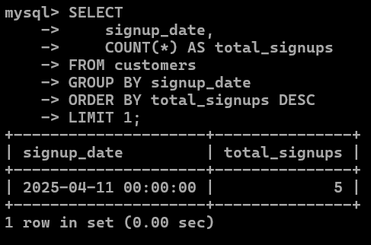
- Add a new column to show the day of the signup date. Find the day with the highest
ALTER TABLE customers ADD COLUMN signup_day VARCHAR(15);
UPDATE customers SET signup_day = DAYNAME(signup_date);
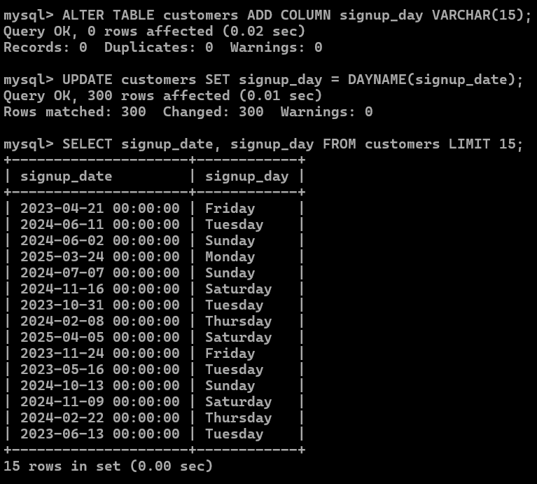
SELECT signup_date, signup_day FROM customers LIMIT 15;

- number of signups.
SELECT
signup_day,
COUNT(*) AS total_signups
FROM customers
GROUP BY signup_day
ORDER BY total_signups DESC
LIMIT 1;
